
Molly Bather Basic Installation Guide
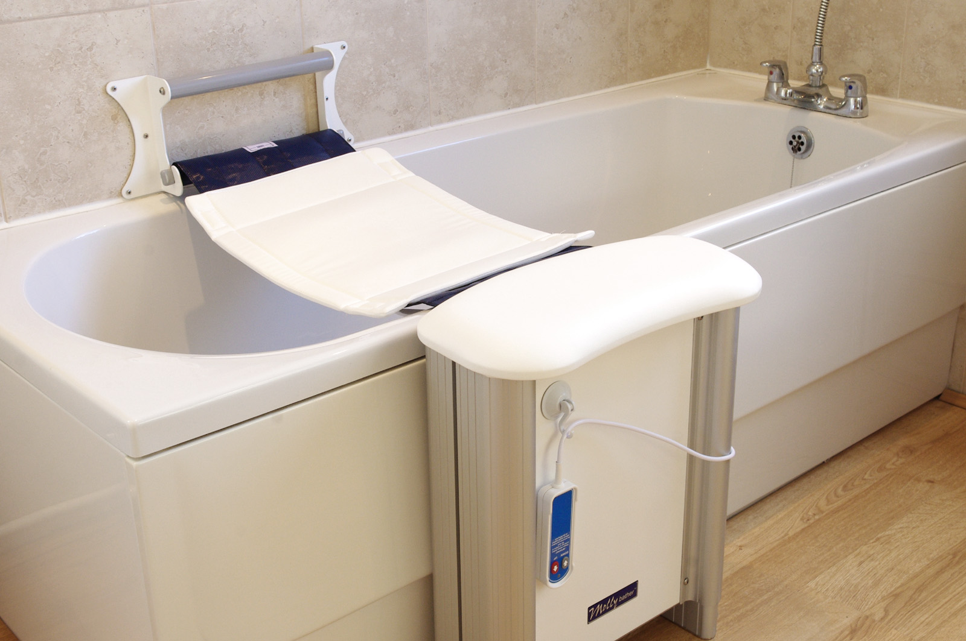

Items supplied with your Molly Bather lift
- 1 Bath Lift with remote control
- 1 Battery pack with charger (provides up to 20 lifts per charge)
- 1 Wall anchor bar
- 1 Belt slip mat
- 1 Manual
- Wall and floor fixing screws for solid wall only.

General Points

- A full installation Guide will be provided with your Molly Bather. This is a basic guide for your convenience.
- It is important that the bath lift is installed correctly. The wall and floor must be sufficiently robust to support the weight of the user.
- Check that the floor mounted unit will not obstruct the bathroom door, basin, WC etc.
- Ensure that the wall where the rail is to be fixed is flat and free of obstructions such as grab bars, soap dishes etc.
- Ensure that there are no concealed water pipes or electrical cables that could be damaged when installing unit to the wall and floor.
- The Molly Bather bath lift is not suitable for baths with bowed front panels. If possible, the bath front panel should be flat or only slightly bowed.

Installing the wall rail
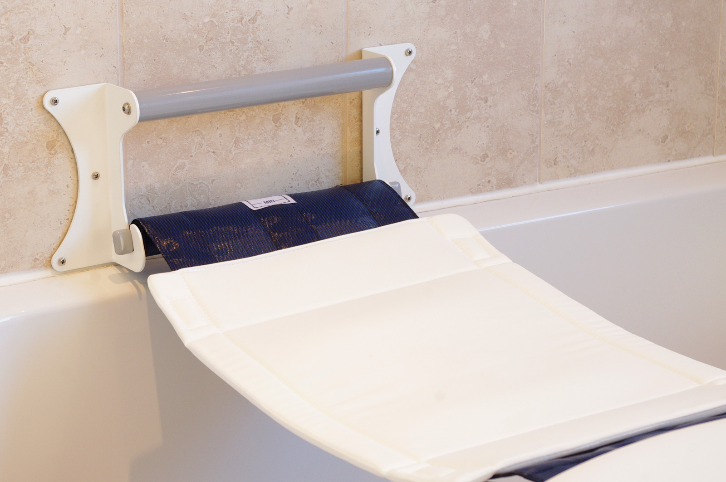
The wall rail has six mounting points, through which the mounting screws, bolts or other fixings will pass.
The holes are at 16 inch centres so as to align with typical stud wall centres.
Position the wall mounting plate against the wall. If the wall is uneven, insert shims or washers behind the rail to level it.
Fix in place using appropriate fixings for the wall type.

Installing the main unit onto the floor
Position the Molly Bather so that the belt runs straight across the bath to the main unit.
Adjust the height of the Molly Bather so that the rubber bungs align with the bath rim.
Fix to the floor using the supplied fixings (concrete or wooden).

Completing the installation

Insert the belt bar into the belt and wind up any excess material as described in the Installation Guide. Insert the bar into the wall rail. Tension the belt using the hand set.
Once adjusted correctly, and the charged battery inserted into the Molly Bather main unit, you are ready to enjoy using your Molly Bather lift

