Practical Bathing Ltd
22 Burfield Road, Old Windsor SL4 2RD
01753 387497

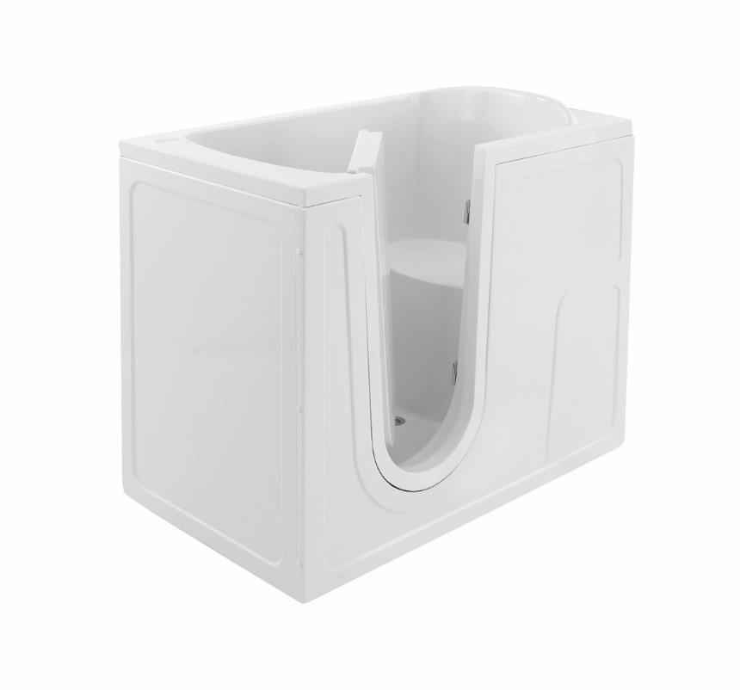
The Oregon Walk in Bath Installation Guide

Please read through these instructions carefully before commencing installation

Safety:
A minimum of two people are required to move these units.
Ensure that all applicable water by-laws are followed during the installation of this unit

Preparatory work
Carefully remove all packaging and inspect the bath thoroughly.
Note: Do not use sharp knives or other sharp edged instruments to remove packaging around the finished surface areas of the bath.

Ensure all component parts are present before proceeding to remove any existing facilities. If any components are missing, please call to advise.

Remove any existing equipment and materials as necessary to prepare the site.

Prepare the floor area and ensure it is flat, level, structurally sound & that there are no services buried within the floor fixing area. Any movement in the floor could result in the bath door leaking.

Fitting the bath
Bring bath into the bathroom and position it precisely where it is to be installed.

Ensure it is level by adjusting the bath feet accordingly. Note: Do not fix the bath yet. It is important to ensure that there is no movement in the floor of the intended position as this could cause the door to leak.

Once placed in position, mark up for the waste by making a mark through the waste hole in the bath onto the floor. Also mark the floor/walls for the appropriate area for the plumbing feeds to enter the bath area.

Mark the wall to accept the metal wall brackets by placing the bracket against the wall, approximately 50mm in from each corner of the bath top edge so that they are tight against the underside of the bath edge.

Drill wall and fit the metal brackets (supplied) to the wall. Check walls for square and note any discrepancies. These must be overcome either by chasing the bath into the wall or by acceptable methods of filling.

Whilst the bath is in position draw a vertical line directly under the corners of the bath where it is touching the walls. These lines will be used for working out the position of the wooden battens to support the bath panels when they are offered into position.

Remove bath from area.

Preparatory plumbing work
Identify the best position for the taps, mark and drill the bath as needed.

Run plumbing feeds to under bath. These should preferably be tank fed supplies in 22mm. Balanced hot and cold is also a preferred alternative.
Note: If mains cold water needs to be utilised with tank fed hot water it will be necessary to fit an adjustable water pressure reducing valve so that the pressure ratio can be evened up to allow the thermostatic valve to operate correctly.

Installation
Offer bath into place once again. Do not force the bath out of square as this will lead to distortion and door leaks.
Move the bath into its permanent installation position, lifting it onto the metal wall brackets and ensuring that the brackets hold it firmly in place.
Note: It is often easier to leave the screws loose whilst placing the bath into the bracket and then tighten the screws after the bath is in place.
Plumb in and run the appropriate waste, allowing where possible the steepest and shortest fall-away to assist in draining the bath. The drainage is to be via a standard 1½ " waste and trap - preferably deep seal. Connect the waste and test.

Fit extended plug and chain

Fill the bath with water to the level of the overflow hole. (This will exert the maximum downward pressure on the bath and the floor beneath it.

Carefully apply a continuous, unbroken bead of silicone to the lip of the bath where it meets the wall to provide a watertight finish between the bath and the wall.

Leave the water in the bath for as long as possible to allow the silicone to cure in the optimum position.

Plumbing
Fitting the Thermostatic valve:
This may be installed in a convenient location and feeds taken to the bath, or is often installed in the bath area so that the bath panels conceal it.
Run a hot feed to the thermostatic valve and plumb into the port marked ‘H’. Repeat for the cold and feed into port marked ‘C’. Take a 22mm feed from the ‘Mix’ mixed feed and run to the hot tap fitted on the bath. This will mean that when the customer opens the hot tap on the bath that ‘mixed’ water will run ensuring that they cannot be scalded by hot water only coming out of the hot tap.

Take a ‘Tee’ off the cold supply before it goes into the thermostatic valve and run this to the cold tap. This allows the customer to draw cold water into the bath, should they so wish.

Note: We recommend that the valve be set approximately 43 degrees C.

Panelling
Fill bath with water and then offer the panels up and trim to suit.
Note: It is preferable to fit the panels when the bath is full of water. This then takes into account the weight of water bearing down on the bath/floor so that the panels can be trimmed to the floor. If you fit the panels tight to the floor and then fill the bath with water the pressure bearing down can cause the panels to spring out.
If for some reason it is not possible to fill the bath with water, ensure a 3mm gap is left between the panel and the floor to allow for downward movement.
Drill and fix wooden battens to support the panels using the lines you marked on the wall as an indication as to the fit of the outside edge of the panel.
Note: Do take into account any return edges on the panels.

Ensure there is no build up of fibreglass or other material where the panel clips locate. A build up in this area will either prevent the clip from gripping the panel or will allow the panel to come loose.

Ease the panel into place. Do not apply sudden or excessive pressure as the panel clip may become distorted or detached from the bath. Should this occur, a two-part contact adhesive should be used to secure the clip back into place. (Ensure the application area is free from dust or grease)

Each panel needs to be drilled to accept screws and cover caps to hold the panel against the wall batten.

Earth Bonding
All metal fittings must be cross-bonded (joined together) to ensure that should electricity be present, it is grounded to earth as quickly as possible. Earth bonding is mandatory whether or not electrical work is carried out. This should be carried out by a qualified electrician and all work must comply with current IEE Regulations.
This means that, should a bath be replaced, then the metal legs of the new bath and the hot and cold taps must be cross-bonded. This also applies to all other metallic fittings. Appropriately rated Earth wire should connect every metal fitting, all of which should be connected to the main earthing system on the house. If plastic pipe is used, then the Earth wire needs to be looped back to the copper feeds.

Testing
The unit is now completed. Ensure the bath is free from debris. Clean the door and seal with clean soapy water removing any grit or build up of dirt. Fill bath with water and check for leaks.
If water should escape from the door seal area, please see the troubleshooting section at the end of this manual.

If there are any cosmetic marks apparent on the finished surfaces of the bath, please refer to the troubleshooting section at the end of this manual.

If the bath fills particularly slowly due to a low water flow rate, please refer to the troubleshooting section at the end of this manual.

Always leave the bath door open when not in use!

Troubleshooting

Water Supply

On tank fed supplies it is sometimes found that the flow rate is poor, resulting in the bath taking a long time to fill. This can often be improved by removing the check valves fitted in the H and C port of the thermostatic valve.

A ‘booster’ pump may also be employed to increase the flow rate. This may be a single or double impeller pump depending on whether just the hot, or both hot and cold water need to be boosted. On a mains cold water and tank-fed hot supply it is essential to fit a non-return (check valve) on the hot water supply. The pump should be fitted as close as possible to the tanks whenever feasible.

As the bath takes a large volume of water it is often beneficial to increase the stored temperature of the hot water. This is important for the winter months, as the cold water being mixed is that much colder. More hot water is therefore needed to allow the correct mixed water temperature to enter the bath. By turning up the temperature of the stored water less hot water is needed to fill the bath to the same level.

Damaged surface

Should the surface of the bath have become marked or scratched it is normally possible to rectify quite simply. Firstly, apply 1000/1200 grade ‘Wet & Dry’ ™ paper, initially using it dry. After the mark has been reduced, use with soapy water. To restore the finish to the bath, apply a cutting paste such as ‘T-Cut’ ™ or ‘Brasso’ ™ and finally finish off with a silicone based polish such as car wax or ‘Mr Sheen’ ™. This is only possible where there is no anti-slip finish, as this will be abraded away if rubbed with wet and dry paper.

Water Escapement (via door seal)

Every bath is water tested before it leaves the factory. However, occasionally leaks can occur. Leaks occurring through the door can usually be traced as:

Distorted Bath - Adjust wall brackets / Ensure bath is not ‘wedged’ against walls and that the floor is structurally sound.

Bath not Level - Level bath as required.

Dirty Door Seal - Wipe seal and door with clean cloth and soapy water.

Flattened Door Seal – Always leave the bath door open when not in use! Occasionally a door seal may become temporarily ‘flat’. Squeeze seal gently to allow it to return to its usual cylindrical profile.

